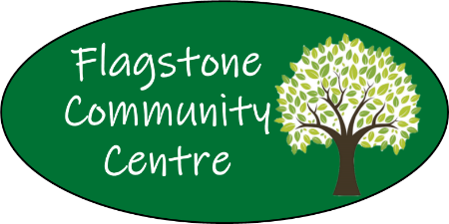
Volunteer/Facilitator
Personal Details

DATE: ______________________________
Name: ____________________________________________________________________________
Phone: ____________________________________________________________________________
Address: __________________________________________________________________________
Email Address: _______________________________________________________________________
In case of an emergency – Next of Kin (Name and Phone): _____________________________________________________________________________________
Please indicate (by circling) which area you would be willing to volunteer for:
Administration Facilitator Cleaning Gardening Promotional/Marketing
Do you have a current Blue Card? FCC delivers Children’s activities
Yes | No
Card Number: __________________________________________________
Date of Expiry: __________________________________________________
If no, we can support you in acquire.
Do you have any health issues or barriers that Flagstone Management need to know about or that we can help you to manage in any way?
__________________________________________________________________________________________________________________________________________________________________________
Please return this form signed and dated back to FCC In person or by emailing the Coordinator cdoflagstone@southmoreton.org.au
Thank you!

